
Institution | IA143
Username | C3-C-2F-218-120-056
Ref. No. | IA143C3-C-2F-218-120-056

Test Report

Linguaskill General

Candidate name

Rohit Malyadri Gadamsetty
Candidate number

2300031803

Date of birth

19 February 2006
Organisation

KLEF C BLOCK VADDESWARAM

Average Score | 160 | CEFR Level | B2

Skill | Test Date | Score | CEFR Level
Listening | 20 May 2024 | 131 | A2
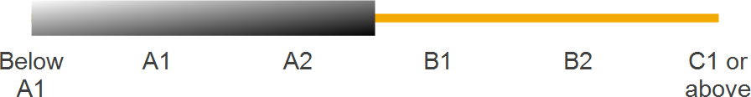 |  |  |  | Can understand the main point of short, clear, sentence-length speech about daily life and work situations. Can recognise phrases and vocabulary closely related to their life, but is likely to rely on repetition, simplified speech, slow speech, or guessing to grasp meaning.

Skill | Test Date | Score | CEFR Level
Reading | 20 May 2024 | 180+ | C1 or above
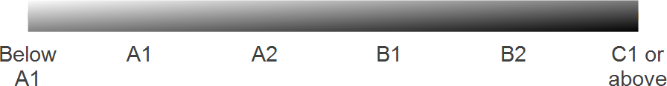 |  |  |  | Can understand long and complex texts on a wide range of topics in daily life and work, including unfamiliar and abstract. Can extract key information and details, and comprehend information that is implied. Can detect the writer’s tone and point of view.

Skill | Test Date | Score | CEFR Level
Speaking | 20 May 2024 | 159 | B1
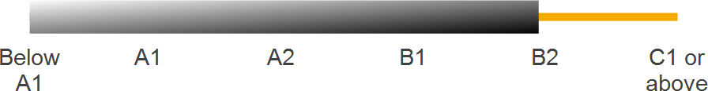 |  |  |  | Can answer questions about routine matters, connecting phrases simply to describe experiences and events and give brief reasons, explanations, reactions or opinions on familiar topics.

Skill | Test Date | Score | CEFR Level
Writing | 20 May 2024 | 163 | B2
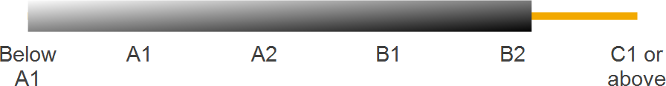 |  |  |  | Can write clear and detailed texts on a range of subjects, which follow standard layout and paragraphing conventions.



CEFR Level Descriptors

Listening

Proficient User | C1 or above | Can understand complex spoken language even on unfamiliar topics.
Independent User | B2 | Can understand complex spoken language on reasonably familiar topics and in a standard dialect.
 | B1 | Can understand the main ideas of clear, standard speech on familiar subjects encountered in daily life.
Basic User | A2 | Can understand the main points of short, clear, slow speech.
 | A1 | Can recognise familiar words and very basic phrases from slow, clear speech.

Reading

Proficient User | C1 or above | Can understand long and complex texts from a wide range of settings, on both familiar and unfamiliar topics.
Independent User | B2 | Can understand texts that contain frequently used vocabulary about familiar subjects.
 | B1 | Can understand short, uncomplicated texts using mainly everyday or work-related language.
Basic User | A2 | Can understand very short, simple texts.
 | A1 | Can understand familiar names, words and very simple sentences in very short, simple texts.

Speaking

Proficient User | C1 or above | Can produce clear, detailed descriptions on a variety of complex topics.
Independent User | B2 | Can produce clear, detailed descriptions on a variety of familiar topics.
 | B1 | Can produce straightforward descriptions on a variety of familiar topics.
Basic User | A2 | Can produce a short series of simple phrases and sentences on familiar topics.
 | A1 | Can produce simple, mainly isolated phrases, on very familiar topics.

Writing

Proficient User | C1 or above | Can write clear, well-structured texts on complex subjects with few errors.
Independent User | B2 | Can write clear, detailed texts on a variety of familiar subjects.
 | B1 | Can write straightforward connected texts on a range of familiar subjects.
Basic User | A2 | Can link basic written phrases and sentences with simple connectors like ‘and’, ‘but’, and  ‘because’.
 | A1 | Can write short, simple, isolated phrases and sentences.

Linguaskill assesses English language ability from below A1 to C1 or above of the Common European Framework of Reference (CEFR). For each skill assessed, candidates are awarded a CEFR level and a score on the Cambridge English Scale. If more than one skill is assessed, an average scale score is awarded. A short description of what a typical candidate can do at the achieved CEFR level is also reported. More detailed ‘Can do’ statements can be found at: www.coe.int/lang-CEFR.
Linguaskill assesses English language ability from below A1 to C1 or above of the CEFR and reports scores from 82 to 180 on the Cambridge English Scale.
180+
160 – 179
140 – 159
120 – 139
100 – 119
82 – 99
C1 or above B2
B1 A2 A1
Below A1
Score
CEFR Level
More information about the Cambridge English Scale can be found at:
www.cambridgeenglish.org/cambridgeenglishscale These results can be validated at: https://results.linguaskill.com


© Cambridge University Press & Assessment 2022

